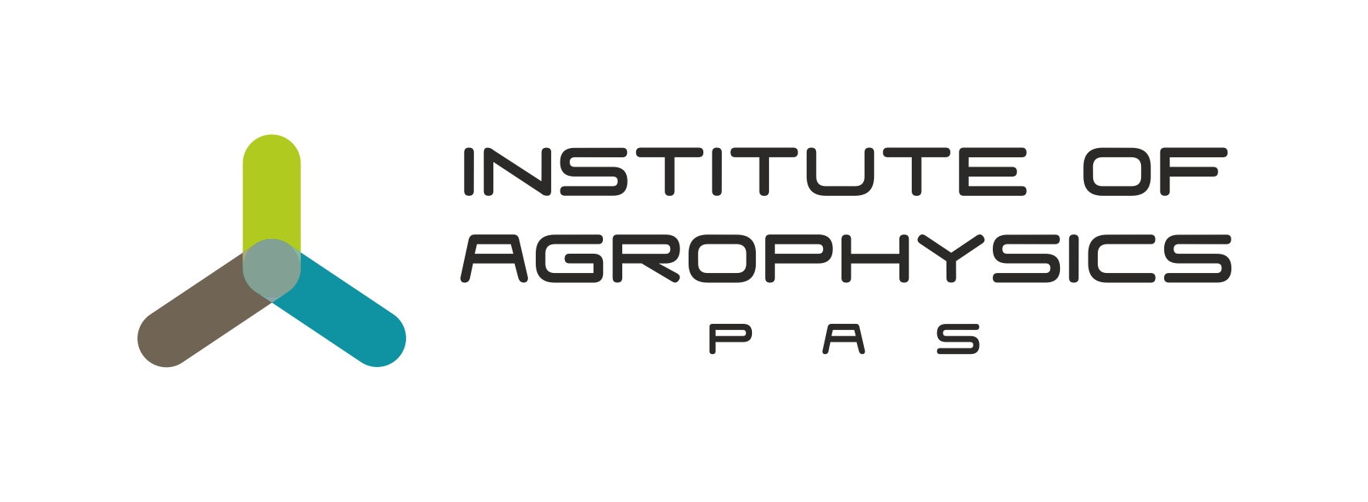
Warsaw University of Life Sciences
together with
Institute of Agrophysics, Polish Academy of Sciences

cordially invite you to the 7th Doctoral Students' Conference titled

"The Four Elements – Contemporary Issues in Life Sciences"

The conference will take place on December 11, 2024, via the MS Teams platform.

The conference is intended for doctoral students conducting research in the fields of agricultural, forestry, veterinary, natural, and technical sciences. The event aims to broaden knowledge and facilitate the exchange of insights under the guidance of the experienced Scientific Council of the Conference.

We warmly invite you to participate!

Participation in the conference is free of charge.

Applications and abstracts should be submitted by November 29, 2024,*
via the registration form available in the "Four Elements Conference" tab
on the website of the Doctoral School of the Warsaw University of Life Sciences: https://www.sggw.edu.pl/nauka/szkola-doktorska

Please, make sure to limit your presentation to 10±2 minutes.

Organizing committee:  M. Sc. Eng. Barbara Dobosz  M. Sc. Małgorzata Chobot  M. Sc. Eng. Justyna Płoska  M. Sc. Eng. Piotr Rusin  M. Sc. Eng. Igor Olech  M. Sc. Eng. Alicja Kızıldağ  M. Sc. Eng. Ewa Szczucka  M. Sc. Karolina Okoń  M. Sc. Adam Furtak | Scientific Council:  D.Sc. Małgorzata Kosicka - Gębska, Prof. SGGW  D.Sc. Justyna Franc-Dąbrowska, Prof. SGGW  D.Sc. Krzysztof Górnicki, Prof. SGGW  D.Sc. Justyna Cybulska, Prof. IA PAN  D.Sc. Artur Nosalewicz, Prof. IA PAN  D.Sc. Joanna Wiącek, Prof. IA PAN
* The number of places is limited, and registration will be on a first-come, first-served basis.
If you have any questions, please contact us via email at: ikn_doktorantow@sggw.edu.pl

